**CAREER**

**RECOMMENDATION.**

**Team Members:**

1. S. Devika (Team Leader)
2. B.Anchal
3. T. Bhavani
4. B. Manavika

***ABSTRACT:***

Welcome to the Go Future Career Recommendation Website, an innovative initiative designed to guide individuals like you towards a fulfilling and successful career path. In today's fast-paced and ever-evolving world, choosing the right career can be a daunting task. With numerous options available and the constant pressure to make the "right" choice, it's easy to feel overwhelmed and uncertain about which direction to take.

In today's rapidly evolving job market, making informed career choices can be a daunting task. With numerous career paths to explore and an ever-expanding range of industries, it's essential to have a reliable resource that can provide personalized guidance to individuals seeking the right career fit. This introduction serves as an overview of the Career Recommendation Project, an innovative initiative designed to offer comprehensive career recommendations and help individuals navigate their professional journeys.

Our project aims to alleviate this stress and provide you with personalized career recommendations based on your unique interests, skills, and aspirations. By harnessing the power of advanced technology and deep understanding of various industries, we can help you make informed decisions that align with your passions and talents.

The primary objective of the Career Recommendation Project is to empower individuals in making well-informed career decisions based on their unique skills, interests, and aspirations. By leveraging cutting-edge technologies, data analysis, and expert insights, the project aims to provide tailored career recommendations that align with an individual's aptitude and future goals. The ultimate goal is to assist individuals in discovering fulfilling and rewarding career paths that maximize their potential.

The Career Recommendation Project employs a multifaceted approach to deliver accurate and insightful career recommendations. The project utilizes state-of-the-art algorithms that analyze vast amounts of data, including educational backgrounds, work experiences, skills, industry trends, and individual preferences. This data is combined with comprehensive career profiles, industry insights, and expert advice to generate personalized recommendations.

The project collaborates with industry professionals, career counselors, and subject matter experts to ensure the recommendations are up to date, relevant, and reflect the evolving landscape of various fields. By considering factors such as job market demand, salary prospects, work-life balance, and growth opportunities, the project provides holistic career guidance that goes beyond superficial assessments.

The Career Recommendation Project offers a user-friendly platform accessible to individuals seeking career guidance. Users are required to complete a detailed questionnaire that covers various aspects of their personal and professional lives, including their educational background, skills, interests, work experience, and career goals. The information provided serves as the foundation for generating personalized recommendations.

Once the questionnaire is completed, the project's algorithms analyze the data and generate a list of potential career paths that align with the user's profile. These recommendations are accompanied by detailed insights into each career option, including job descriptions, required qualifications, salary ranges, and growth prospects. Users can further explore each recommended career path and access additional resources, such as relevant courses, certifications, and networking opportunities.

**SURVEY:**

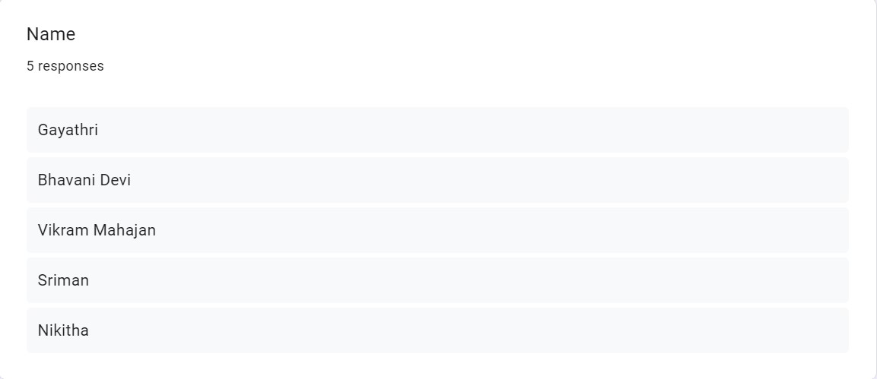

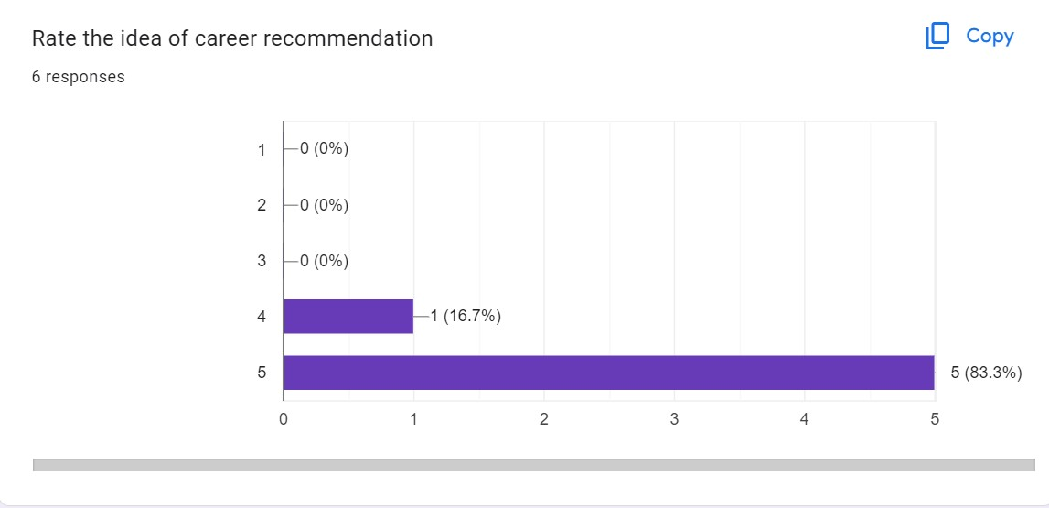

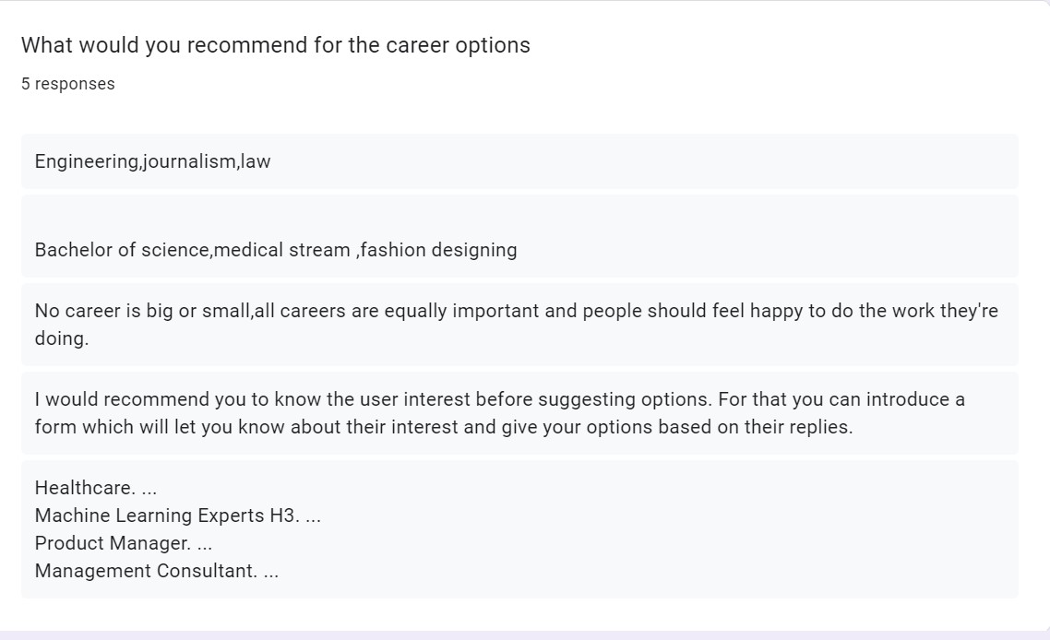

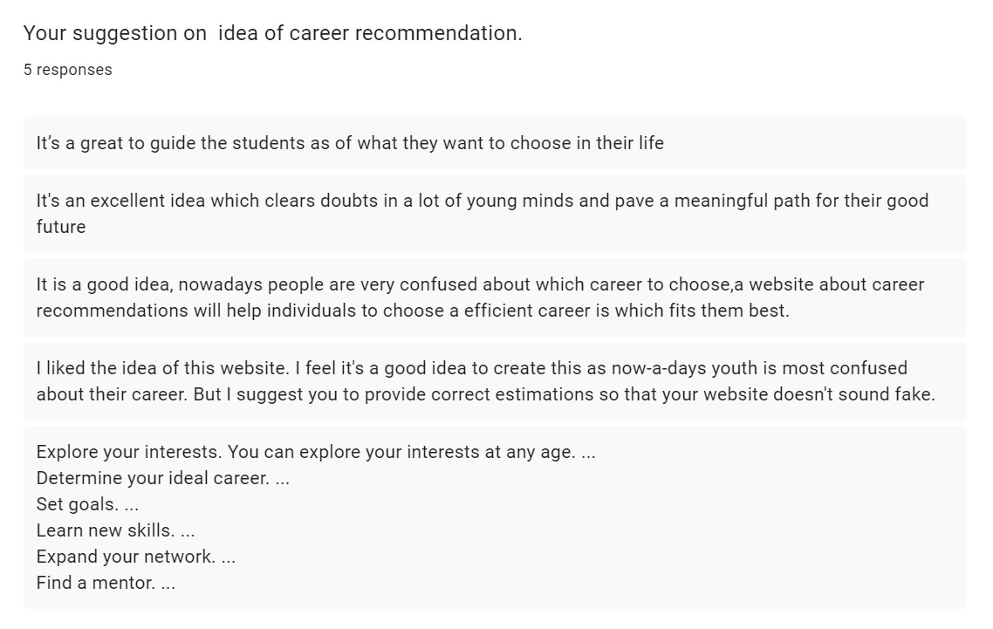

***PROCESS MODEL***:

A process model for a Career Recommendation Project typically involves several stages or steps. Here is a general outline of a process model that can be adapted and customized according to the specific requirements of your project:

**Requirement Gathering:**

* Identify the target audience (students, professionals, career changers, etc.) and their needs.
* Determine the scope and objectives of the Career Recommendation Project.

**Data Collection and Preparation:**

* Develop a comprehensive questionnaire or survey to collect relevant information from users.
* Gather data from reliable sources, such as career databases, industry reports, and labor market statistics.

**Algorithm Development:**

* Design and implement algorithms that leverage machine learning, data analytics, and statistical modeling techniques.
* Define the criteria and metrics for assessing compatibility between user profiles and career options.

**User Interaction and Interface:**

* Create a user-friendly platform or application where users can provide their information and interact with the recommendation system.
* Design an intuitive and visually appealing interface to enhance the user experience.

**Recommendation Generation:**

* Process the user-provided data and apply the developed algorithms to generate personalized career recommendations.
* Consider various factors, such as skills match, interests, career growth opportunities, salary prospects, and industry trends.

**Validation and Refinement:**

* Conduct validation tests to assess the accuracy and effectiveness of the generated recommendations.
* Collect feedback from users and experts to identify areas for improvement and fine-tune the recommendation system.

**Additional Resources and Support**:

* Provide users with supplementary resources, such as recommended courses, certifications, workshops, or networking opportunities related to their recommended career paths.
* Offer guidance and support through expert advice, career counseling services, or access to industry professionals.

**Evaluation and Monitoring:**

* Establish metrics and indicators to evaluate the performance and impact of the Career Recommendation Project.
* Monitor user satisfaction, engagement, and success rates in terms of career outcomes.

**Iterative Development and Enhancement:**

* Maintain an iterative development approach, incorporating user feedback and technological advancements to continually improve the project.
* Regularly update the recommendation system to reflect changes in industry trends, job markets, and emerging career paths.

**The Reason behind using Waterfall process model in this project is:**

The Waterfall process model is a sequential and linear approach to software development that involves distinct phases, with each phase being completed before moving on to the next. While it may not be the most suitable choice for all projects, there are certain scenarios where the Waterfall model can be beneficial in many ways like:

**Well-defined Requirements**: When the project requirements are clear, stable, and unlikely to change significantly, the Waterfall model works well. It allows for upfront planning and documentation of requirements before development begins.

**Predictability and Stability**: The Waterfall model is advantageous when there is a need for predictability and stability in terms of timelines, costs, and deliverables. Each phase is completed before moving to the next, reducing uncertainty and allowing for better project management.

**Simple and Small Projects**: The Waterfall model is suitable for smaller projects with straightforward requirements and a limited scope. The linear nature of the model makes it easier to manage and control the project progress.

**Client Involvement**: If the client prefers to have a clear understanding of the project scope and deliverables upfront, the Waterfall model can provide that level of visibility. The client can review.

**Documentation Emphasis**: The Waterfall model places significant emphasis on documentation at each stage. This can be beneficial when there are strict regulatory or compliance requirements.

Stable Technology and Tools: If the project utilizes stable and well-established technologies and tools, the Waterfall model can be effective. It avoids the need for constant adaptation to new technologies and allows the team to focus on the predefined set of tools.

Once the programming is completed, the testing is done. In this model the sequence of activities performed in a software development project are:

Requirement Analysis

Project Planning

System Design

Detail Design

Coding

Unit Testing &System Integration Testing

BUDGET:

The budget of the project as per our analysis will be Rs.150/-